INSTALLATION,OPERATION,MAINTENANCE MANUAL

KEEP THE MANUAL NEAR THE MACHINE ALL TIME
AND MAKE SURE ALL USERS HAVE READ THIS

TRUCK TIRE CHANGER

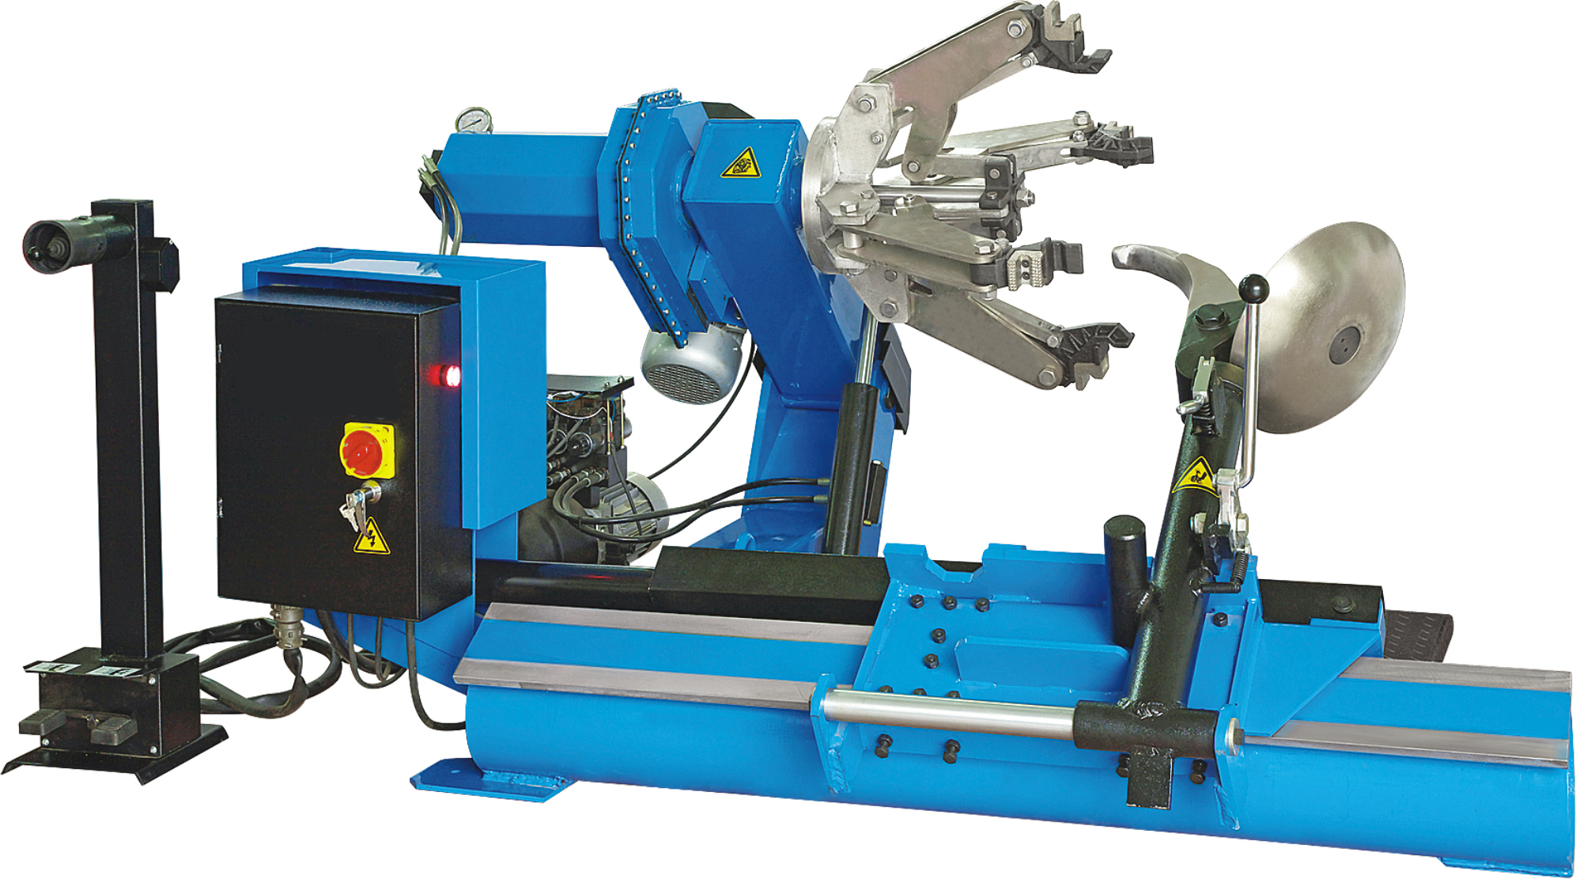

KEEP THE MANUAL NEAR THE MACHINE ALL TIME
AND MAKE SURE ALL USERS HAVE READ TH
Type: NAT Truck Tire Machine
Main Dos and Don’ts
1.1 Introduction
Thank you for buying and using this tire changer. This introduction is the important information for this kind of production. Please read the instruction carefully before using or fixing the machine. Please take good care of it. So that it can develop it advantages.

1.2 Dos and Don’ts
When using this machine .If you are not the person who operate the machine.
Don’t stand close to the warning sign .Don’t remove it.
If you operate the machine incorrectly. Our company will not be responsible for it.

1.3 Safe rules
The machine should be fixed in a safe place according to the safe rule. The position must ventilate and be sure that there is enough space around it.
If we put the machine is in the open air. You must put up a shed to prevent it from the sun, the rain. You shouldn’t use it, when there are inflammable cargo and perishable goods around it .
Don’t fix the machine in a place where it is too hot or too wet.
Too much dust ammonia alcohol thinner or spray and bond are not allowed on the surface of the machine.
If you want to operate the machine without cutting off the electricity .You should have the specialize knowledge.
The person without being trained can’t operate the machine.
Technical number

2.0 Technical number

Height ---------------900~1300mm
Length ---------------2100mm
Width ---------------1500m
Weight ---------------515kg
The range of bold plate ---------------14”~26”
Motor power---------------1.8kw
Speed---------------7.34 r/min
Power supply---------------380V 50HZ
Operation supply---------------24V

2.1 The range of using
The range of the iron circle---------------14”~26”
Max wheel diameter---------------1500mm
Max wheel width ---------------780mm

Warning: You mustn’t charge the tire when
the tire is on the machine.
If you want to move the tire that
is large enough, more than two
people are needed.

2.2 The function of every part

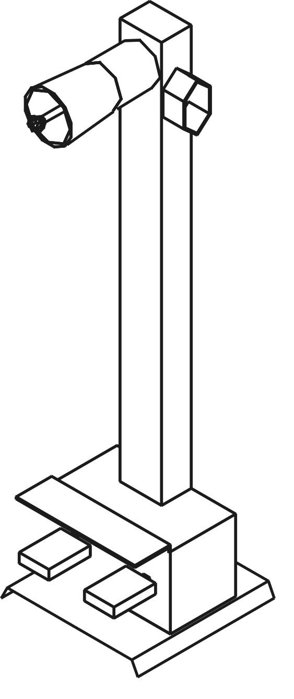

2.moveable control parts
Removing the tire from every parts. It is very convenient to use this machine.
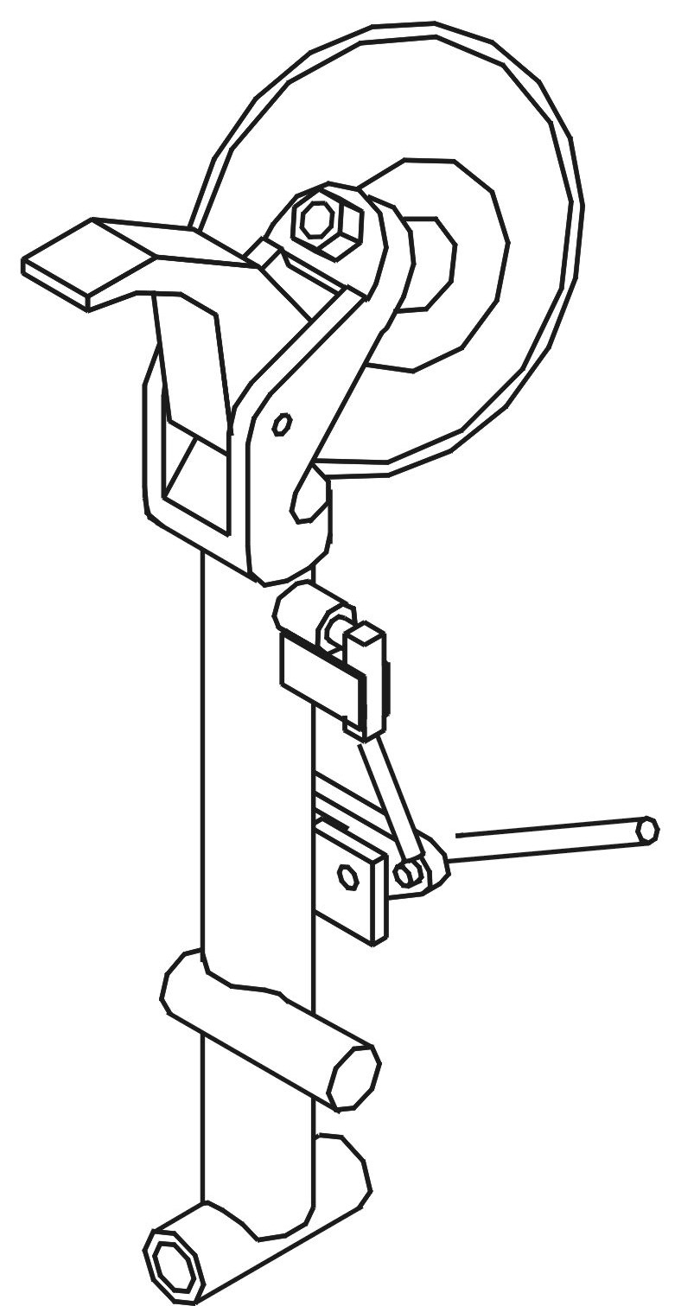

3.Tool arm
Removing hook and plates can go around quickly.
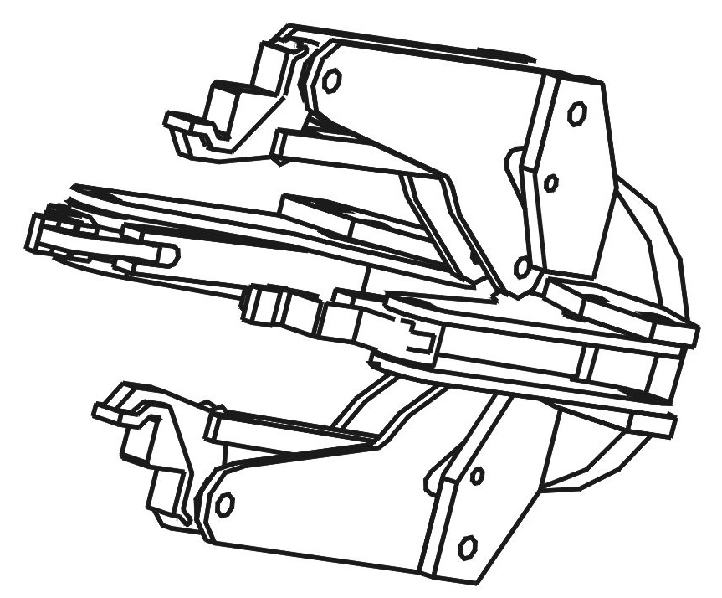

1.Blocking plate with four feet
The lifting tire can make tire go clockwise and anti-clockwise. The open and close of the blocking plate can be controlled by hydraulic system.

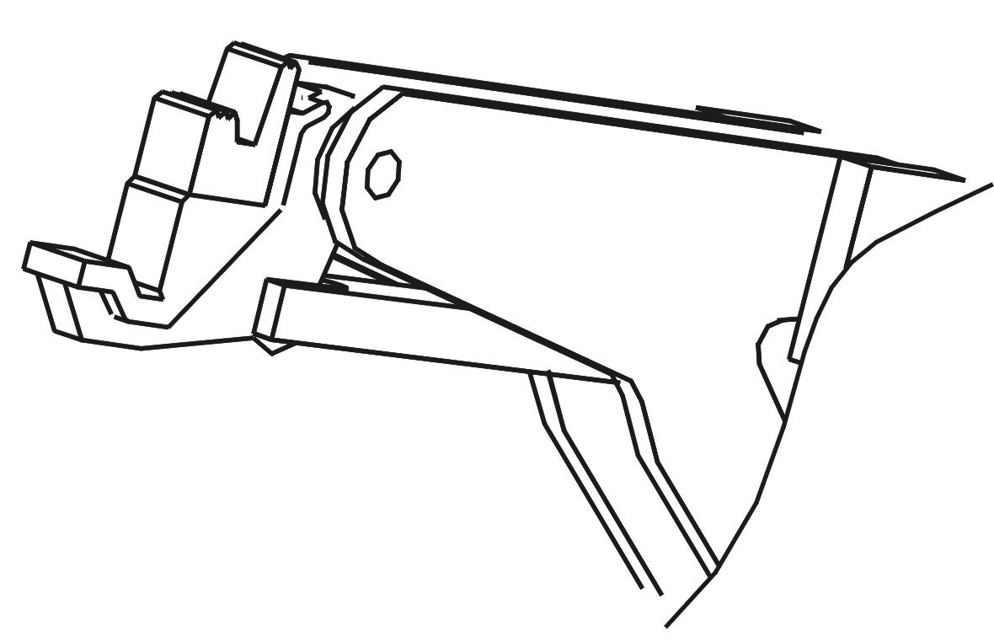

4.Locking tighten claw
This machine can block the tire iron circle, This design can choose different ways of locking tighten.

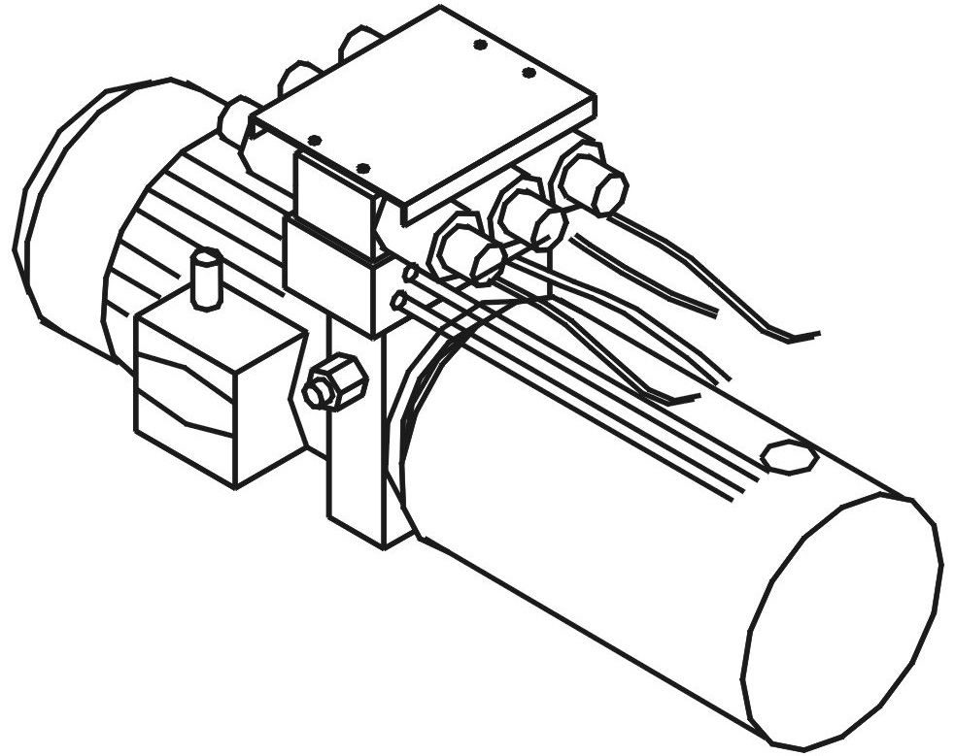

5.Hydraulic pressure
It can adjust the pressure of the blocking plate. All kinds of iron circle are in a safe condition.

2.3 The function of the parts with the machine

1.Crow
When you remove the tire with
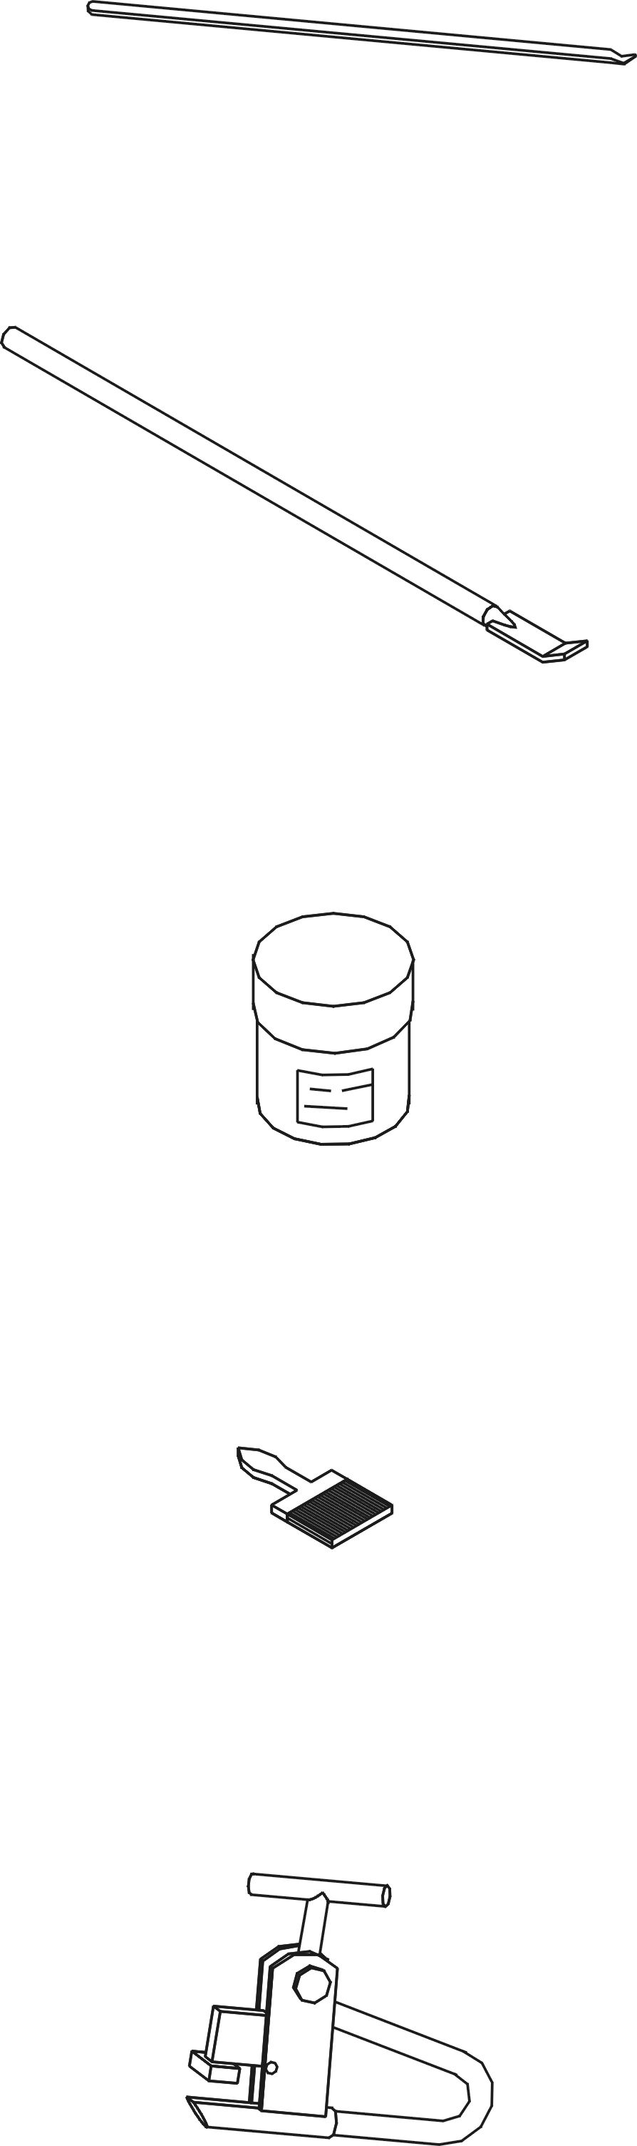
press bar. Use it to get rid of the press
bar by pitking it on the plate

2.Crow
When you remove the tire
which is tighten. you should use
removing hook and plate.

3.Lubricant
Before removing the tire .
you should put some lubricant
between the mouth of the tire
and the iron circle.

4.Brush
You can use it to brush lubricant

5.wheel circle clips
The function of the clips is
that it can avoid the circle on the
iron circle when we fix it.

6 Telecontrol handle please see the 3.3-3 for use instruction
Transportation fixing adjusting
3.0 Professional terms
1.Moveable control part 2.Crossing switch
3.Block plate switch 4.Pedal switch
5.Electrical switch 6.Mixing electric box
7.Tool box 8.Oil tank
9.Hydraulic pressure valve 10.Circumvolve envelop
11.Pressure watch 12.Worm wheel box
13.Belt cover 14.Swing arm
15.Block plate 16.Locking paws
17.Decompression 18.Plate
19.Orientation part 20.Tool arm
21.A lifting car 22.Paralleling board
23.Tool arm hook 24.Tool arm slide way
25.Paralleling side way 26.Condole ear
27. Telecontrol controller 28. Telecontrol receiver

3.1 The instruction of removing boxes
This kind of machine must be transported, in the original packing box. You must put it according to the sign.
The machine that has been packed must be transported by forklift at the certain tonnage.
After you get rid of the package. You should examine it .If you have any questions. Please connect with seller.
If you find plastic production, nail, bolt, wood, etc. You must put it in the safe place.
Warning:When you remove the machine .
Please wear gloves. So that it will
not hurt you .
When you pack or move the machine,
Don’t touch the plastic parts.

3.2 The fixing of the machine
3.2-1 The space of fixing
In order to use the machine safely, there must be enough space around the machine.
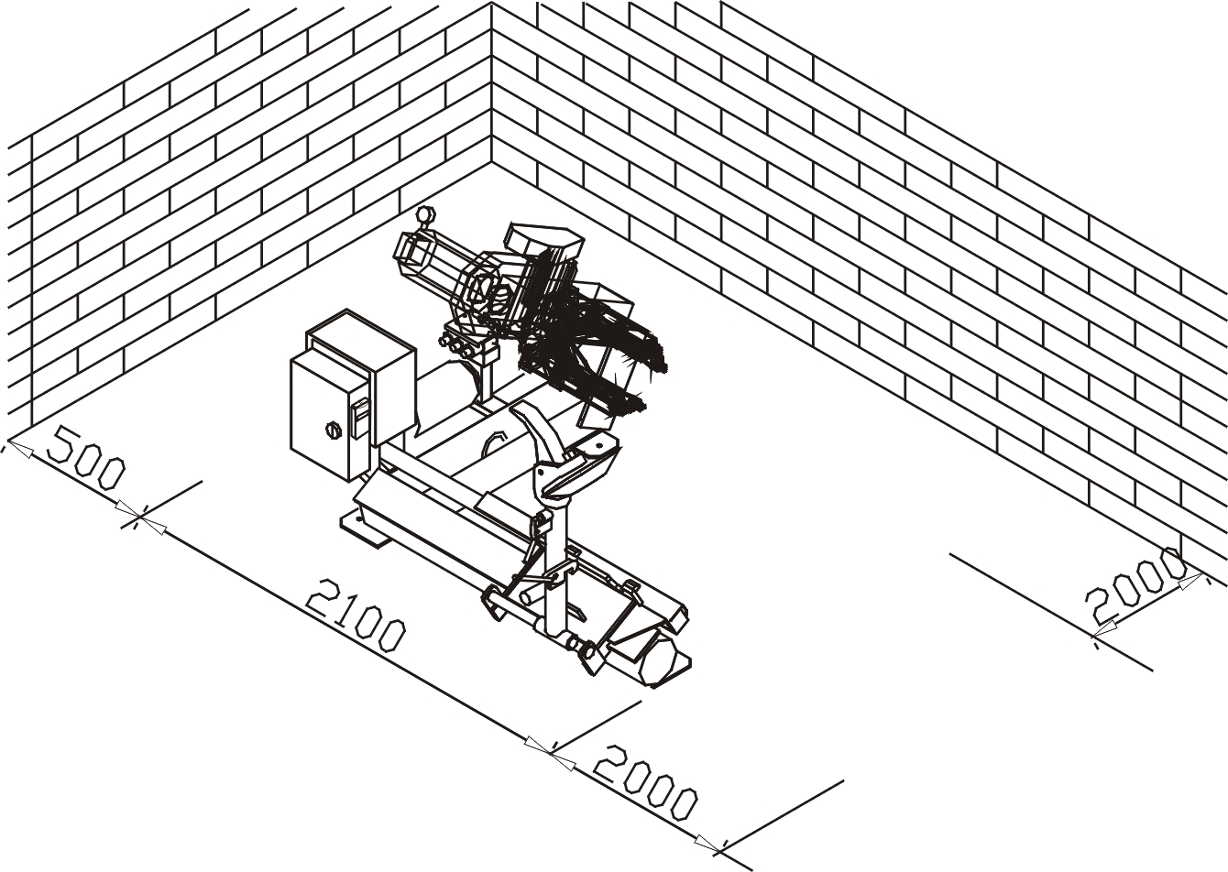
3.2-2 The fixing of the machine
When the tire is over 1000kg the machine must be fixed by bolt, the ground must be flat.

3.2-3 The connection of the electrical equipment
All the electrical equipments must be fixed by professional worker.

Before fixing or connection. You must check power supply. The electrical must not be protected by fuse, also have better cover.

Moveable control parts.
The connector plugs in the moveable control parts must connect with the electrical outlet in the bottom of the mixing electric box.

The connection of the main power supply
Three electrical outlet is in the tool box. It connected with electrical net . connector plugs must be pluged.

Checking the changing direction of hydraulic pressure
After connecting with the power supply, Turn on the main switch in the cupboard of the electricity .The changing direction of the hydraulic pressure should be same as the sign direction in the protective cover of the motor power .If the direction is opposite. You can change two “Three parts electrical wire” either in outlet or in connector plugs.
Warning: If the motor power turn around to
the opposite direction for a long time
time. It will be burnt down.

3.3 Equipment Adjusting

3.3 Equipment adjusting
3.3-1 Putting oil in Put 46# hydraulic oil in the tank (8) of
hydraulic system
After putting some oil in, moue three hydraulic vat(paralleling moving vat, lifting vag, keeping pressure vat ),Get rid of the air in the vat .Then put more oil in it, until vat poles in three vats move to the end of the tank.
Pay attention: When you begin to move the
machine, You will find that every
oil vat does not move smoothly.
Perhaps there is some air in
it, move it several times. this
phenomenon will disappear.

Put some gear oil in the worm wheel box. When the swinging arm is in the lowest place, gear oil is just pass the oil window, The oil is enough.

3.3-2 Adjusting
Before using the equipment, Everyone must do the working experiment. Before adjusting, press the handle on the locking tighten hook (23) of the tool arm down, prick up the tool arm, that is to say it mustn’t be in the position of working.

Crossing switch(2)upward swinging arm (14)upward
Crossing switch (2)downward swinging arm (14)downward
Crossing switch to the (2)left small paralleling board left
Crossing switch(2)to the right small paralleling board right
Blocking plate switch(3) upward and downward
Four blocking paws open and close, When they open widely enough, Pressure watch will show the flank pressure of the oil in keeping pressure vat.
Step on the pedal switch(3)four blocking paws will turn in clockwise or anti-clockwise direction.
3.3-3 Signification for telecontrol handle key-press
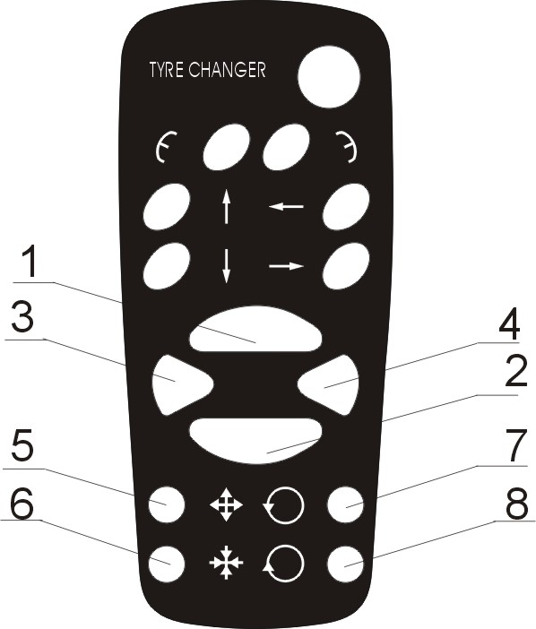
1 swinging arm (14) upward
2 swinging arm (14) downward
3 small paralleling board left
4 small paralleling board right
5 Four blocking paws open
6 Four blocking paws close
7 four blocking paws will turn in clockwise
8 four blocking paws will turn in anti-clockwise direction

The removing and fixing of the tire
Pay attention: When you adjust the machine,
tool arm must it be in the
position of working.
You hands and other parts of
you body, Will be far away
from the machine.

4.1 Locking tightenly of the tire
Put the tire on the lifting car. move the car.
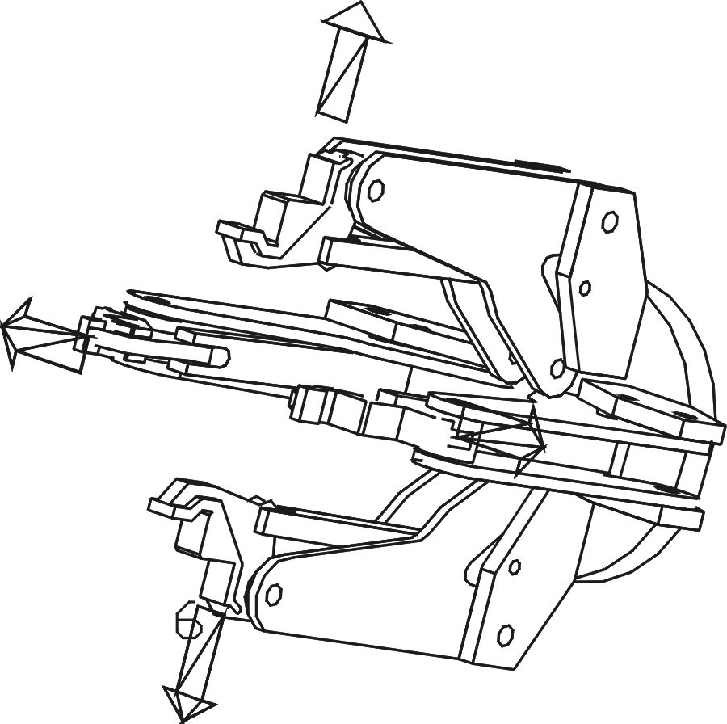
Automatical fixing heart blocking plate will produce high pressure (see the right picture).The range of the adjusting is 2-15 mp. Pressure watch will show the pressure. If the wheel circle is very thin. You should reduce the pressure.
Blocking plate can lock all kinds of wheel circle from 14” to 26”.

4.2 The ways of blocking tire by using locking tighten paws.
There are four locking tighten paws in the blocking plate. It can

lock the different kinds of wheel circle.
There are many different kinds of ways of locking according to the wheel (see the following pictures).

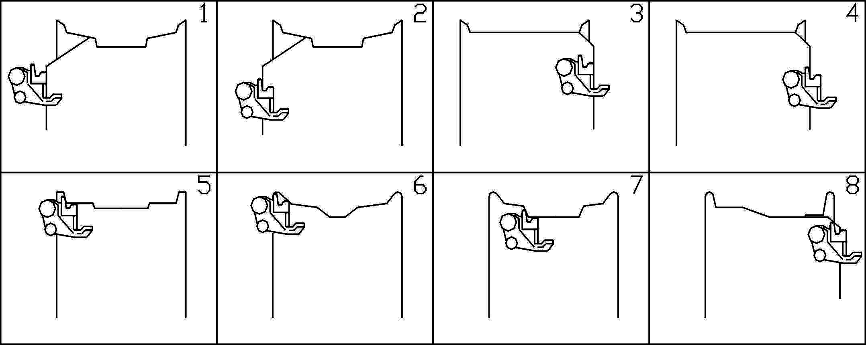
Usually vacuum tire use the 1 and 2 method and the tire with press bar use the 3 and 4 method.

4.3 Removing and fixing the tire with inner tube.
4.3-1 Reducing the pressure and lubricating.
(1)Check if the locking tighten hook hooks the lifting board . The removing and fixing hook mustn’t be in the position of working.
(2)Make sure the tire has been clipped, there is no air in the tire.
(3)Adjust the position of the tire. The plate has just been away from the rim . Make it be close to the rim.
(4)When you turn around the tire , move the tool arm and press the tire down until tire is separated with the rim.
(5)Put more lubricant between the rim and edge of the tire.
(6)Make the plate prick up the tool arms, put the plate on the other side of the tire, until other side of the tire is separated with the rim , put some lubricant in it.

Pay attention :
Lubricant must be put.
When you reduce the pressure outside you should follow anti-clockwise direction. When you reduce the pressure inside, you should follow clockwise direction.
When you reduce the pressure inside. Removing and fixing hook must be in the position of 4-7.

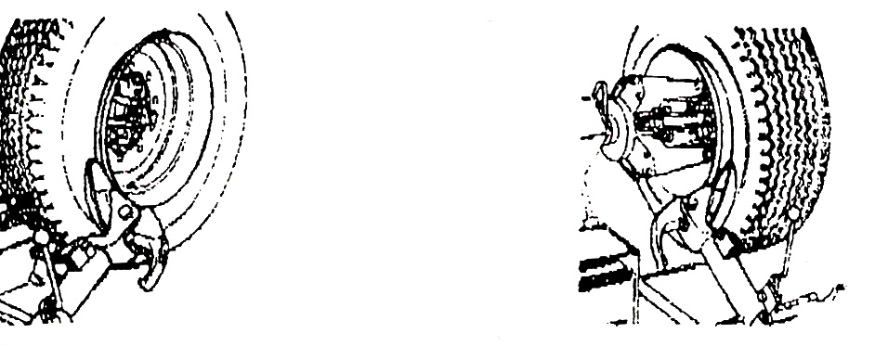

Picture 4-1 picture 4-2

4.3-2 (Removing the tire without inner tube )
(1)Move the tool arm to the outside of the tire , make removing hook face the tire Make sure that locking tighten hook has tightened . Orientation parts are in its position.
(2)Adjusting the position between removing hook and the tire . The removing hook must be in the position between the edge of the tire and the rim. Move the fool arms so that the removing hook can insert the tire at the same time , it can pull the edge of the tire outside.
(3) Press the tire , move the tool arms outside little by little .
Repeat this action , let the removing hook swing downward so that
the removing hook can pull the edge of the tire(see picture 4-3).
(4)Turn the tire in the anti-clockwise direction , until all the tire has been separated.
(5)Move the tool arm to the inside pull the edge of the inner tube also move it to the outside of the rim . Turn the tire , until the edge of inside separated from the rim.
(6)We can use plate to remove the edge of the inside tire by pushing the edge of the tire out of the rim . Press the tire down . Make the plate between the rim and the edge of the tire . Turn the tire(see picture 4-5). You can see crow to help you.

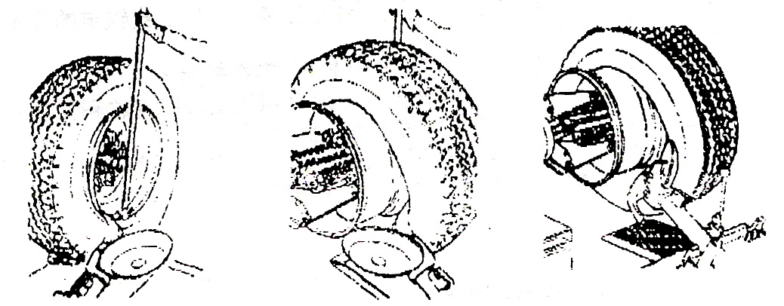

Picture 4-3 Picture 4 - 4 Picture 4-5
Pay attention:
You must be concentrated, examine the movement parts carefully, avoid it from damage.
Examine the tire when it was weighted. Adjust the position of tool head and rim.
Removing and fixing hook must be in the position of 4-5.When you use plates.

4.3-3 Fixing the tire without inner tube
(1)Lubricate the wheel circle and the edge of tire.
(2)Tighten the outside of the tire in the highest position by using wheel circle clip(see picture 4-6).
(3)Adjust the position of iron circle by using the lifting car. Make sure that the wheel circle clip is in the highest position of rim. Adjust the angle of the tire, and make the tire and rim cross together.
(4)Adjust the position of removing and fixing hook. The position of it must between rim and the edge of the tire. The distance to the edge of tire is about 5mm(see picture 4-7). Turn the tire in the clockwise direction. The tire is fixed.
(5)Prick up the tool arm, unload wheel circle clip push the tire inside. Fix the wheel circle clip on the rim and turn it to the upward of the removing and fixing hook.
(6)Adjust the position of the removing and fixing hook and make it between the edge of tire and rim. The distance to the rim is about 5mm.Turn the tire, until the outside edge of the tire has been fixed.
(7)Take out the removing and fixing hook. Take the wheel circle clip out.

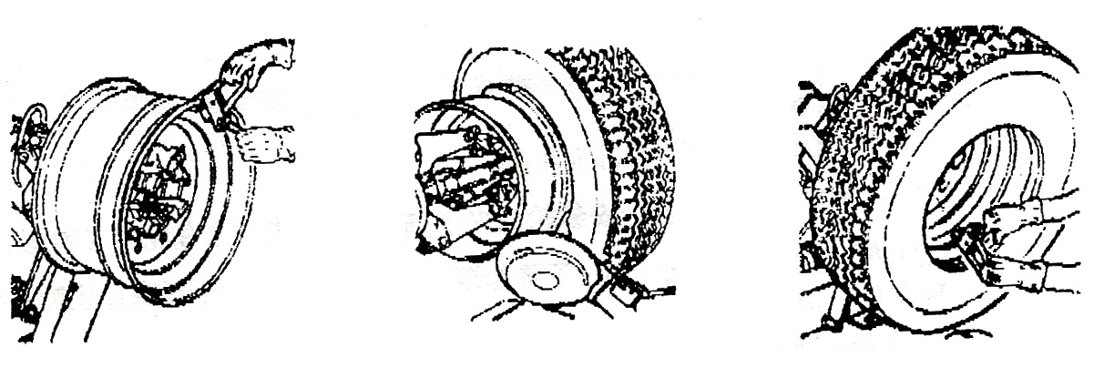

Picture 4-6 Picture 4-7 Picture 4-8

Notice: When you remove and fix the tire.
Orientation and Locking tighten hook of
tool arm must be in the position of working.

4.4 Removing and fixing the tire with inside tire in it.
4.4-1 The lubricant of the tire with inside tire in it.
(1)When you let the air out, open the pipe of the fixing gas mouth , press it in the tire , so that there isn’t obstruct.
(2)Repeat 4.3-1 action.
Notice: Because there is inside tire in it. After
finishing the action of reducing pressure,
you should stop moving the plate, so
that use won’t damage the inside tire.

4.4-2 Removing the tire with inside tire in it.
(1)Removing the outside edge of the tire. The same as 4.3-2.Hook the edge of the tire with removing and fixing hook. Insert a crown, sledge the outside edge of the tire by pressing the crown down, lower the tire down. The distance between the head of the removing and fixing hook and the edge of the tire is about 5mm(see picture 4-9). Turn the tire in the anti-clockwise direction, you can remove the outside edge of the tire.
(2)Removing the inside edge of the tire: Pick up the tool arm, lower the tire down and make it touch the lifting car. Move the lifting car outside, you can take the tire out by using the lifting car, you can get the inside tire out. After doing it, the action is just the same as the course(see picture 4-10).Remove the inside edge of the tire.
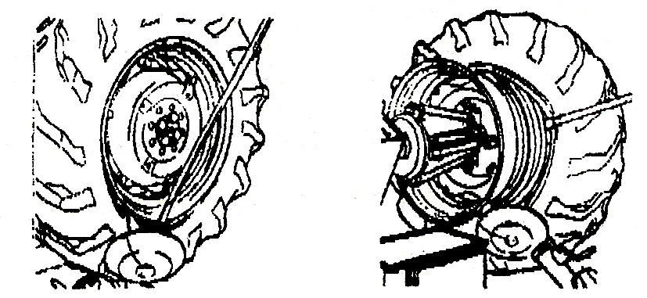

Picture 4-9 Picture 4-10

4.4-3 Fixing the tire with inner tube.
(1)Put some lubricant on the edge of the tire and the rim.
(2)You should fix the wheel circle clip in the highest place of the rim. Make sure the wheel circle clip block the wheel circle.
(3)Put the tire on the lifting car. Lower the wheel circle (wheel circle clip must be in the highest position). Make the wheel circle hook the side of the tire.
(4)Raise the wheel circle, turn the tire in the anti-clock wise direction little by little. The tire can lean automatically.
(5)Adjust removing and fixing hook and you can hook the edge of it from inside. Turn the tire in the clockwise direction until the edge of the tire is finished. Take the wheel circle clip.
(6)Turn the tire the gas hole faces the bottom.
(7)Lower the wheel circle, let the tire get close to the lifting car. Move the lifting car outward, you can use lifting car to help you move the tire a certain distance away.
(8)Put the inside tire in it. Turn the iron circle in the clockwise direction, put the inside tire in the rim.
(9)Put a little gas in the tire. So that, it won’t be broken when we fix it.
(10)Lifting the tire and fixing the wheel circle clip outside the rim. It is 20cm to the right of the gas mouth. Turn the tire until the wheel circle is in the position of nine o’clock.
(11)Adjusting the equipment of the removing and fixing hook. It is 5mm to the rim.
(12)Turn the tire in the clockwise direction until the tire is fixed on the rim.
(13)Lower down the tire and check if the gas hole is exactly faces the hole.
(14)If the position is mot exact, let the tire lean on the lifting car. Turn the wheel circle little by little.
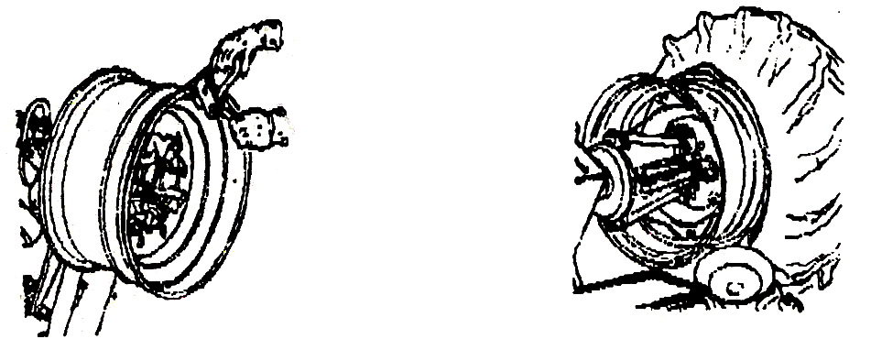

Picture 4-11 Picture 4-12
4.5 Removing the tire with opening mouth press bar.
4.5-1 Removing the tire with opening mouth press bar.
(1)Fix the tire as above. Make sure there is no air in the tire.
(2)Adjust the plate and make it face to the tire, and get close to it.
(3)Turn the tire, and move the tool arms towards inside. If the edge of the tire has been separated. Stop moving so that we couldn’t damage the inside tire(see picture 4-13).
(4)Sledge the press bar with crow in the opening and pull if with plate. Turn the tire in the anti-clockwise until the press bar to fall down (see picture 4-14).
(5)Insert gas mouth inside the tire.
(6)Put the plate on the other side of the tire. Push and turn the tire, until half of the tire has been pushed out(see picture 4-15).
(7)Lower the tire, make tire touch the lifting tire car, move if outside, you can get tire.
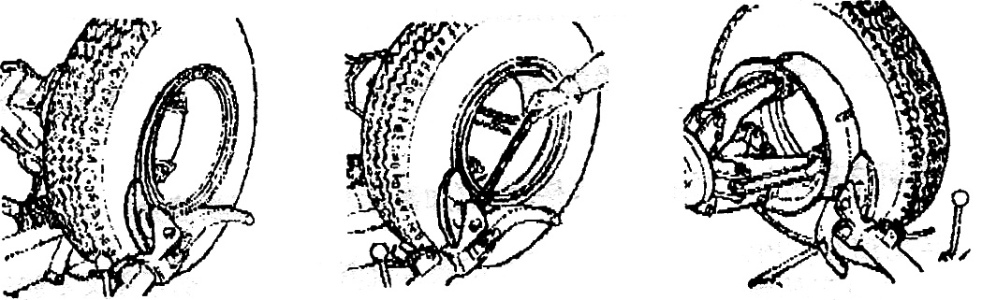

Picture 4-13 Picture 4-14 Picture 4-15

4.5-2 Fixing the tire with opening mouth press bar.
(1)Fix the wheel circle, put the hole in the gas mouth in the bottom. Brush lubricant in it.
(2)Put the tire with inside tire on the lifting car the gas mouth should be put in the bottom.
(3)Move the lifting car, make the tire enter the iron circle.
(4)You can turn the circle little by little. Adjust the position of the gas mouth.
(5)Make the plate face the tire, press the blocking circle and the opening mouth press bar. Turn the tire and the fixing is over.
(6)Prick up arm tools, remove tire (Don’t charge the tire on the equipment).
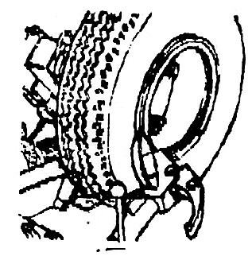

Picture 4-16

Maintenance
Warning: If you don’t read the instruction carefully
we won’t be responsible for it.

5.1 Maintenance
You must follow the instructions on cleaning periodically.
You should cut off the power supply.
Clean the machine itself and the movement parts (slide way, blocking plate, etc.).
Cleaning the following parts periodically by adding some lubricant (slide way, blocking plate, tool head, Orientation parts of tool head).
Change gear wheel oil for worm wheel box.
The equipment has sign of putting oil in.
Tighter the bolts periodically in fixing parts.
(1)Adjusting the bolts periodically in slide way. Make it not only work correctly but also be sure the distance between them.
(2)Adjusting the bolts in paralleling movement small board (see picture 5-1). Tighten the bolts in the upper place of the paralleling movement small board. After using the machine a period of time, push the paralleling movement small board according to the direction (in picture 5-1), loosening the fixing bolt on the upper place of the paralleling small board. Adjust the slide block and bolts. Then tighten all the bolts.(The bolts shouldn’t be neither too tight nor loose.)
(3)Adjust the bolts in the four paws blocking plate (Don’t be too tighten.)

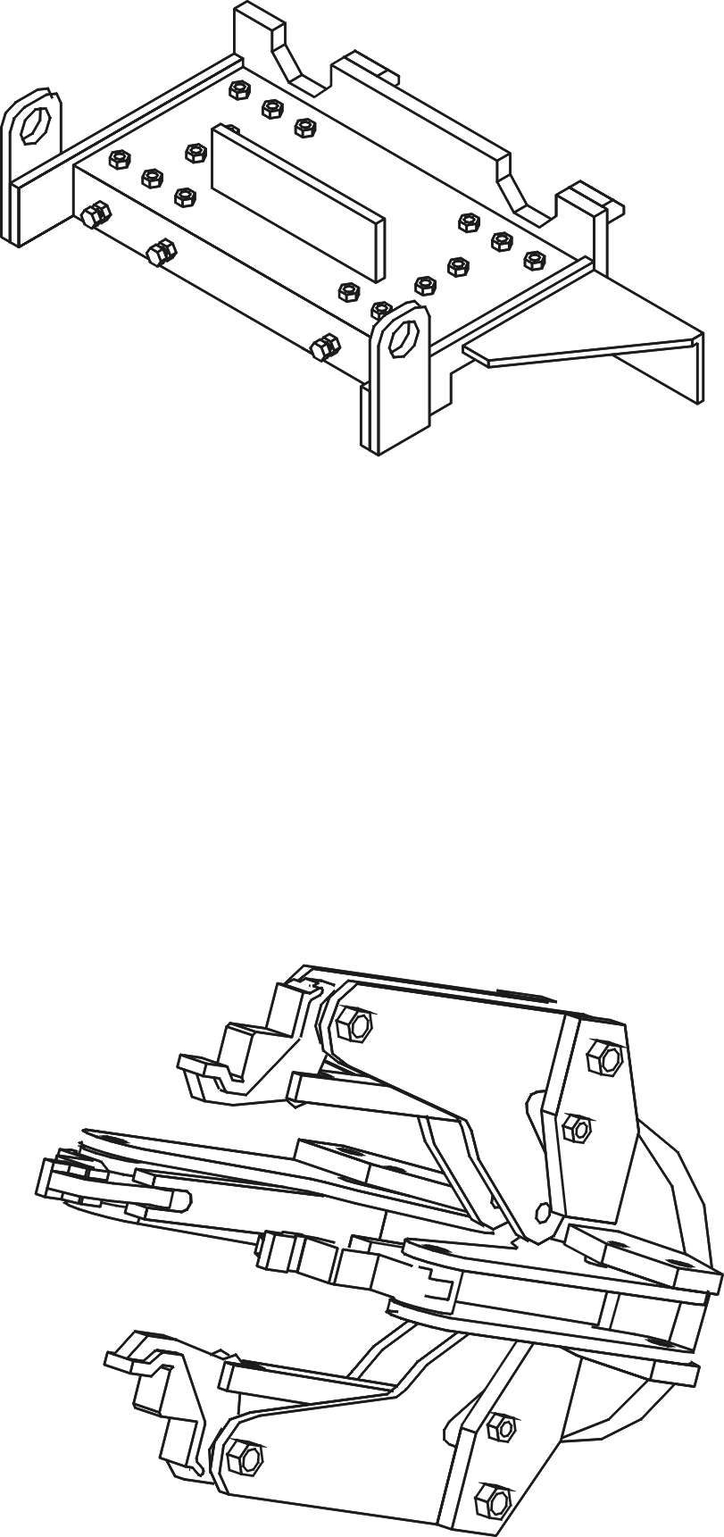

Picture 5-1

Picture 5-2

Check the tension and tighten of the belt. If it needs adjusting, get down the belt cover adjust the tension and tighten.

5.2 Maintenance
Storage: Properly preserved if the machine won’t be used for a long time.
(1)Lower the lift boom.
(2)Take block plate back.
(3)Pull out the electrical plug.
(4)Spread oil on the sliding groove of bracket.
(5)Clear away the tanker.
(6)Spread oil on cross-axle of assembly.

